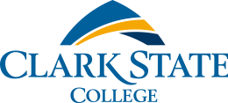

SEO Audit Report

Prepared by Jeris Payne

**Table of Contents**

Contents

**SEO Overview** 4

**Audit Results Summary** 4

**Content Inventory** 5

Results 7

Recommendations 7

**SEO Technical Audit of the Clark State Website** 8

Title Tags 8

Meta Tags 9

H1 and H2 Tags 9

Response Codes 10

**Clark State Keyword Analysis** 12

Results 12

Recommendations 12

**Competitive Keyword Analysis** 14

Results 14

The Ohio State University 14

Wittenberg University 15

Wright State University 15

Cedarville University 16

Sinclair Community College 17

Recommendations 17

**Robots.txt File** 18

Results and Recommendations 18

**Mobile SEO Audit** 19

Problems and Aesthetic Issues 19

Rel=”alternate” Tags 21

Rel=”canonical” Tags 22

Google Mobile-friendly Test 22

Google’s Mobile Speed Test 22

Mobile First Index Tool 22

**Overall Recommendations** 24

# **SEO Overview**

This is an SEO audit for clarkstate.edu which must be done as an assignment for WDD 3300. SEO audits are used to analyze how a website is performing and how it ranks on search engines such as Google, Bing, and Yahoo. Audits are like a roadmap to help you maximize your visibility. Audits help keep your website’s performance up to date and ensure long-term success. It is important to perform an audit to optimize search engine visibility, usability, and conversion.

# **Audit Results Summary**

This audit will provide a summary of my findings along with content that is found on Clark State’s website. It will also include a technical audit of the Clark State website on desktop and mobile devices and list any pages that showed an unsatisfactory status code. You will see an analysis of the keywords that Clark State uses on their website and how they compare to the keywords used by competing colleges. I will also provide my suggestion for a robots.txt file. Finally, I will list all my suggestions and recommendations for how to best improve Clark State’s SEO.

# **Content Inventory**

A content inventory documents every piece of content on your website. In this audit, I am only doing a content inventory for Clark State’s homepage since this alone provides us with an adequate amount of links that allow us to examine Clark State’s SEO. This content inventory is limited to the homepage; however, this may not be the case for each analysis later in this report. Content inventory is important because it allows you to evaluate your site’s content and can be used to better organize a website and improve outcomes. To create the content inventory, I used Google’s developer tools to view the sources tab and see all the underlying HTML. The screenshots below provide an overview of the links that were found only on Clark State’s homepage.

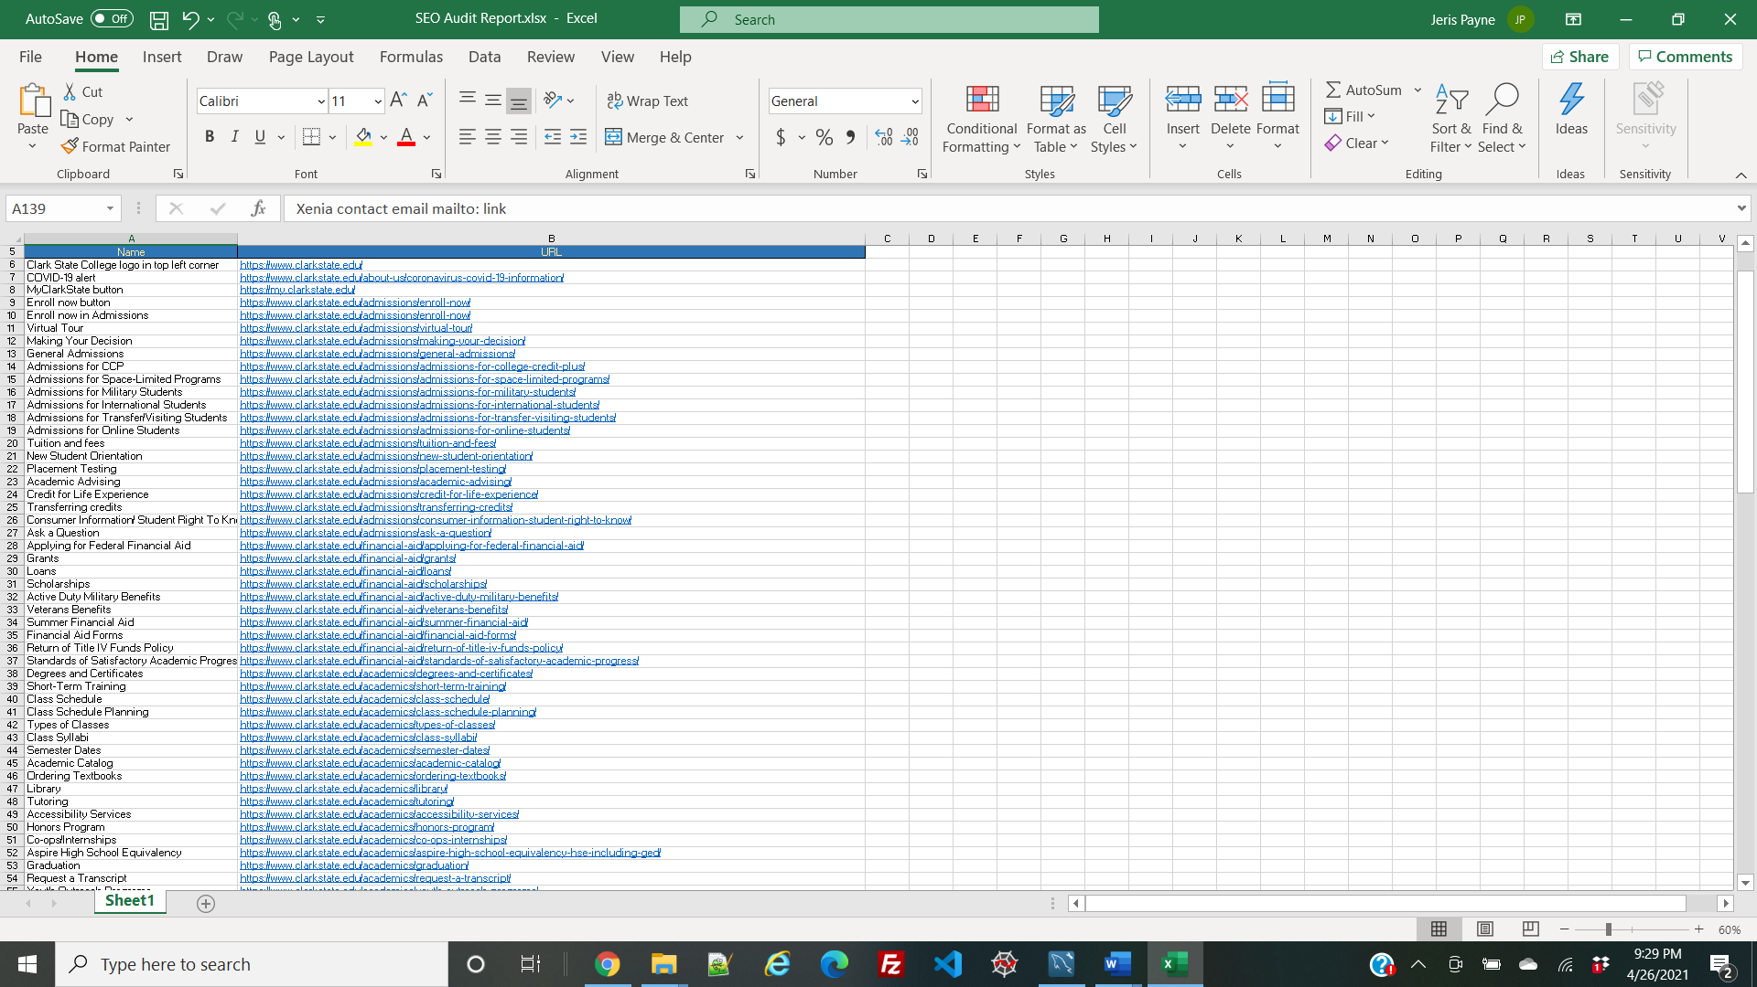

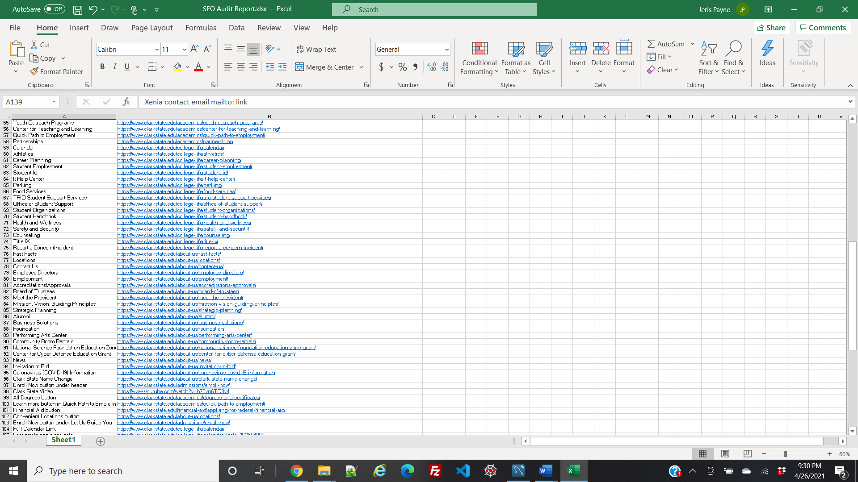

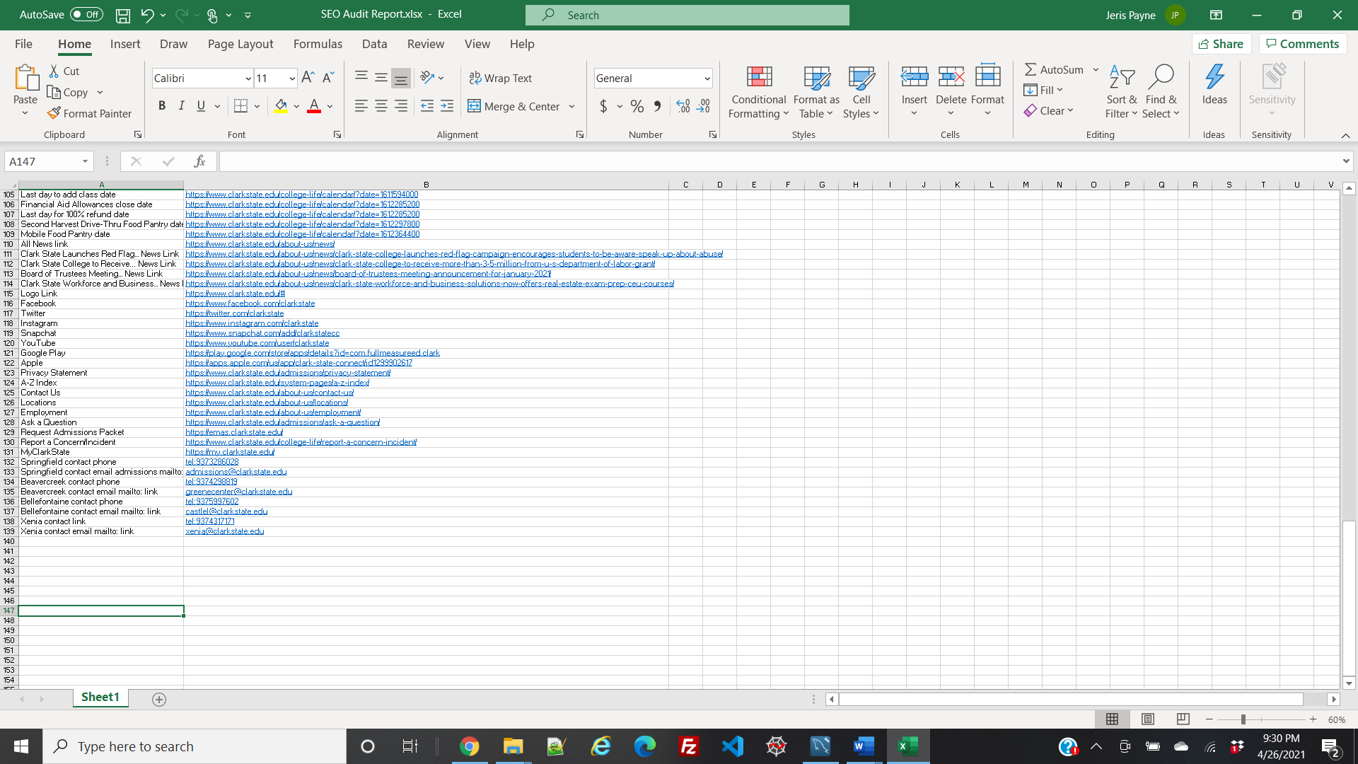

## Results

Clark State has a total of 139 links just on the homepage. According to SEO standards, it is suggested to have no more than 100 links on a page. While there usually is no SEO penalty for going over the 100-link limit, it may interfere with user experience. A user can easily get overwhelmed by a large number of links and may not be able to find what they are looking for and leave the page unsatisfied.

## Recommendations

I recommend at least going through the homepage and determining which links are the most important. By determining importance, you may be able to reduce the number of links or maybe even find some that are no longer relevant.

# **SEO Technical Audit of the Clark State Website**

An SEO technical audit is a process where you check the technical aspects of a website’s SEO. In this case, I reviewed the title tags, meta tags, H1 tags, and response codes. Technical SEO is important because it affects your rank on search engines such as Google. The better your technical SEO, the higher you can prompt the search engines to rank you. SEO consist of both technical and non-technical elements. The technical side of SEO includes anything that is part of a website. The non-technical side of SEO includes anything that is not part of your website content. To perform the audit on Clark State’s website, I used a web crawling tool called Screaming Frog. I conducted the technical audit based on the results Screaming Frog provided.

## Title Tags

Title tags are used to show preview snippets for a page on a search engine. This makes title tags important because they help display a concise picture of the content available on a website. Upon viewing the title tags, I found two issues that occurred on multiple home page links. The first is a duplicated title. Duplicated titles are trouble for SEO because they may result in multiple pages competing for search ranking results. Out of all the links, I only found six that have duplicated titles. To fix this I suggest either renaming a title or determining if both URLs are truly needed.

The second error I found is making the titles too long. I found a total of 112 pages with this error. For best SEO results, all titles should be under 65 characters long. This allows for an effective message to be displayed in the search results. To fix this, I recommend rewriting the title to make it shorter and only include words that clearly state what the page is about.

## Meta Tags

Meta tags appear in a page’s source code and provide a description of the content on that page. Meta tags are important because they impact the amount of people that click on a website and how a website appears in SERPs. They can also impact traffic and engagement rates which can directly impact a website’s SEO rankings on a search engine. In the Screaming Frog results, it showed that none of the pages included a meta tag. Meta tags are important because a copy of the meta tags is provided on the search engine result page giving the user an idea of what is included on the web page. Not providing a meta tag may lower Clark State’s SEO ranking. In order to increase Clark State’s ranking, I highly suggest adding a meta tag to each page.

## H1 and H2 Tags

An H1 tag shows the largest text on the page and serves as a title for that page’s content. H2 tags serve as a subtitle for that same page. H1 and H2 tags are important because the search engines look at them to determine how to rank a page. H1 tags are also important because they are displayed on the page as a page header. Without these tags, the page most likely will not rank well at all. I found 21 pages without H1 tags, 159 pages without H2 tags, and 13 pages without H1 or H2 tags. To fix this, I recommend including an H1 and H2 tag that way your page has a chance at a higher ranking. When adding an H1 tag, make sure you include a term that you’d like the page to rank for. For example, since Clark State is a college it might want to rank for terms such as “college”, “higher education”, “associate degree”, etc.

## Response Codes

When crawling clarkstate.edu, I found multiple pages with inadequate HTTP response codes. HTTP response codes are important to SEO because they help make sure your content is accessible to search engine crawlers. When they request content, the best response code to have is 200 which means a request was successful. 301’s are okay as well because they let browsers and search engines know that a webpage has been replaced by another page, however, I would keep them to a minimum. What we don’t want are response codes in the 400’s and 500’s. Screaming Frog returned three 400 response codes, two 403 response codes, and fourteen 404 response codes. All these codes mean that there is a problem on the client-side. A 400-response code may mean that the web page is no longer available or that the user is not allowed access to it. To fix this, I recommend changing it to a correct live URL and removing all site references and links to it. A 403-response code means that the web page is forbidden to the user and the user, therefore, can not access the page. To fix this, I recommend taking up the issue with your website’s hosting company and determining if this is truly a page you don’t want a user to access. If it is, add a friendly error message for the user. A 404-response code indicates that a page was not found or does not exist. To fix this, you need to put a custom 404 error page together that includes the navigation and a friendly error message for the user.

# **Clark State Keyword Analysis**

Keywords are the phrases that you use in your web content that make it possible for people to find your website on search engines. Keywords are important to SEO because the more relevant they are to your audience, the more likely they are to visit your website. Implementing keywords will help Clark State rank above its competitors. To use the best keywords, you need to know how people are looking for the services and information you offer. To figure out how effective Clark State’s keywords are, I used websites such as <https://trends.google.com/trends/?geo=US> and <https://soovle.com/> to see how popular they are during different times of the year and how they compare to other keywords.

## Results

The main keywords that Clark State uses are

* “State”
* “Clark State”
* “Clark State College”
* “State College,
* “College”
* “Page”
* “State Community”
* “State Community College”
* “clarkstate”

These are pretty good keywords, especially the more specific ones such as, “Clark State College” because they help narrow what appears in the search engine. It is much easier to compete with specific keywords than broad keywords such as “college”.

Soovle helps determine how a keyword ranks on different search engines. The keyword “State” is pretty broad and comes up with a several different state-related suggestions. “State College” on the other hand, is more specific to education and ranks pretty high on all search engines. “Clark State” ranks high on search engines however, on Answers.com, Lewis-Clark State College ranks higher than Clark State does. “Page” isn’t a very descriptive keyword and doesn’t really relate to Clark State other than the fact that you may be searching for one of their web pages.

## Recommendations

Add more keywords that way Clark State has a chance of being viewed on a search engine. You can add keywords in title tags, meta description tags, meta keyword tags, in the headers and sub-headers, and in the page content. I recommend adding keywords such as

* “State college OH”
* “Clark State Sports”
* “Clark State Eagles”
* “Clark State Campus”

It is a good idea to target about two or three keywords per page, even if they are just close variations.

# **Competitive Keyword Analysis**

A competitive keyword analysis gives you an idea of the difficulty involved in ranking for a certain keyword and how many webpages you need to beat to claim a high ranking. Competitive keyword analysis can be used to help you rank above your competitors. It can help you improve your site and be used to identify the strengths and weaknesses of your site and your competitors. To do a competitive analysis I first determined what colleges may be Clark State’s top competitors. I then viewed their source code to determine what keywords they use.

## Results

I determined that these colleges are Clark State’s top competitors:

* The Ohio State University
* Wittenberg University
* Wright State University
* Cedarville University
* Sinclair Community College

Wittenberg and Wright State and Cedarville are all relatively close to the Springfield area making them a first choice for anyone who may want to stay at home. OSU is the first choice for any athlete making it a big competitor. Sinclair is a big competitor due to the fact that it is also a community college, their tuition is lower, and it is also close to Springfield.

## The Ohio State University

OSU uses keywords and phrases such as,

* “The Ohio State University: OSU”
* “Ohio State”
* “Big 10”
* “Buckeyes”
* “graduate and undergraduate programs”
* “University”
* “Scarlet and Gray”

All of these keywords are relevant to the college and relate to what people may type in a search engine to find OSU. OSU also has a large social media presence on all social platforms. They also have a high grade on Niche.com.

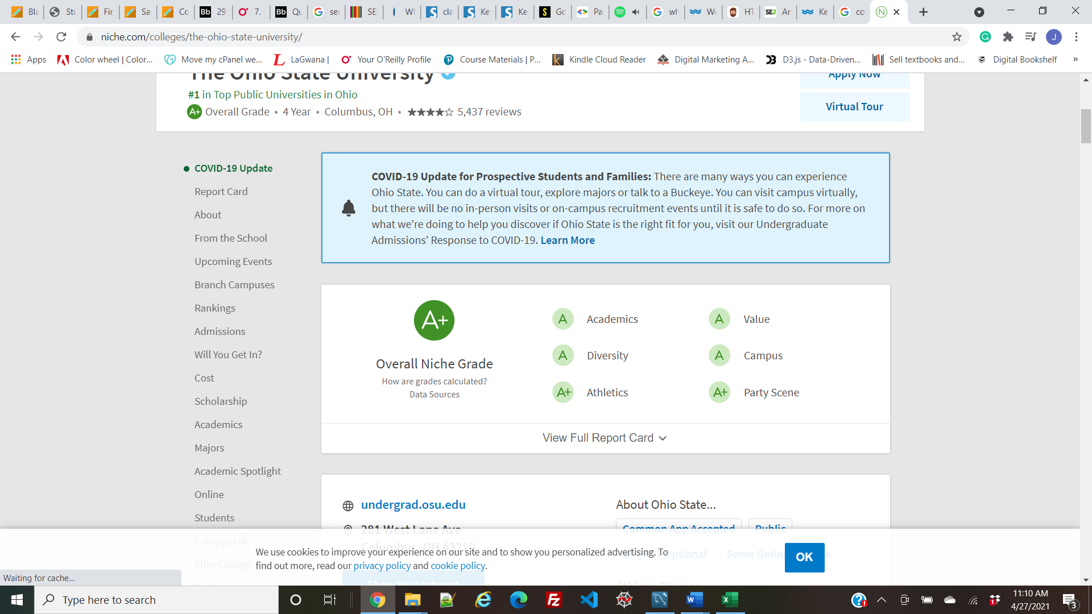

## Wittenberg University

Wittenberg uses keywords and phrases such as,

* “Wittenberg”
* “liberal arts”
* “Division 3”
* “NCAA Division III”
* “Ohio colleges”
* “Lutheran colleges”
* “Midwest colleges”

They do not use any non-brand keywords. Wittenberg also has a social media presence on all social platforms. While their Niche grade is lower than OSU’s, it is still pretty highly graded.

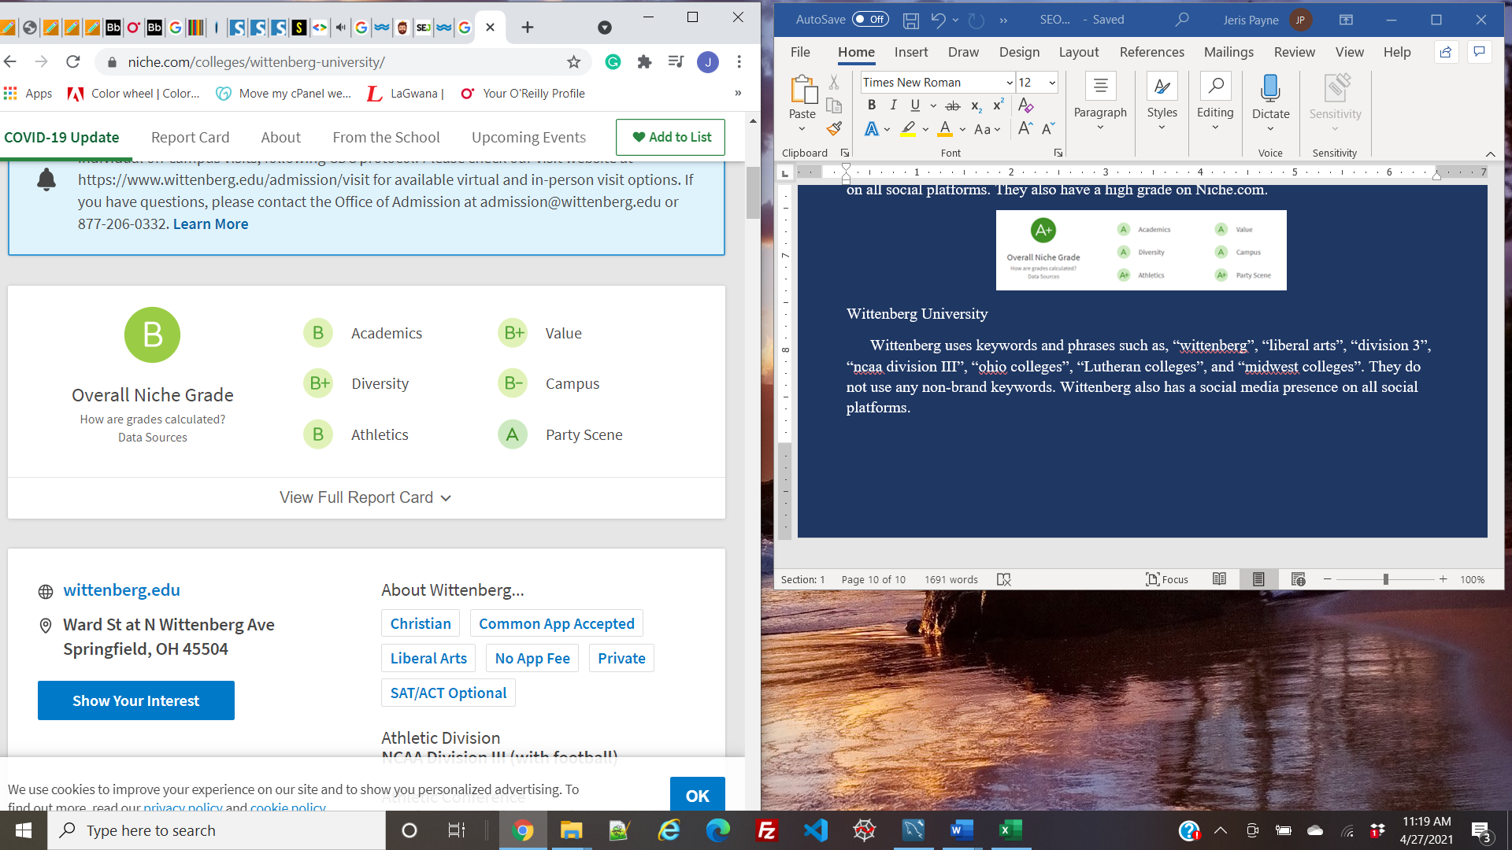

## Wright State University

Wright State uses keywords and phrases such as,

* “Wright State University”
* “Ohio”
* “Dayton”
* “Celina”
* “WSU”
* “Rowdy Raider”
* “undergrad”
* “graduate school”
* “lake campus”

Wright State also has a large social media presence on all social platforms. Although they have one of the lower Niche grades, the location and majors offered at the college may be a large factor in their popularity.

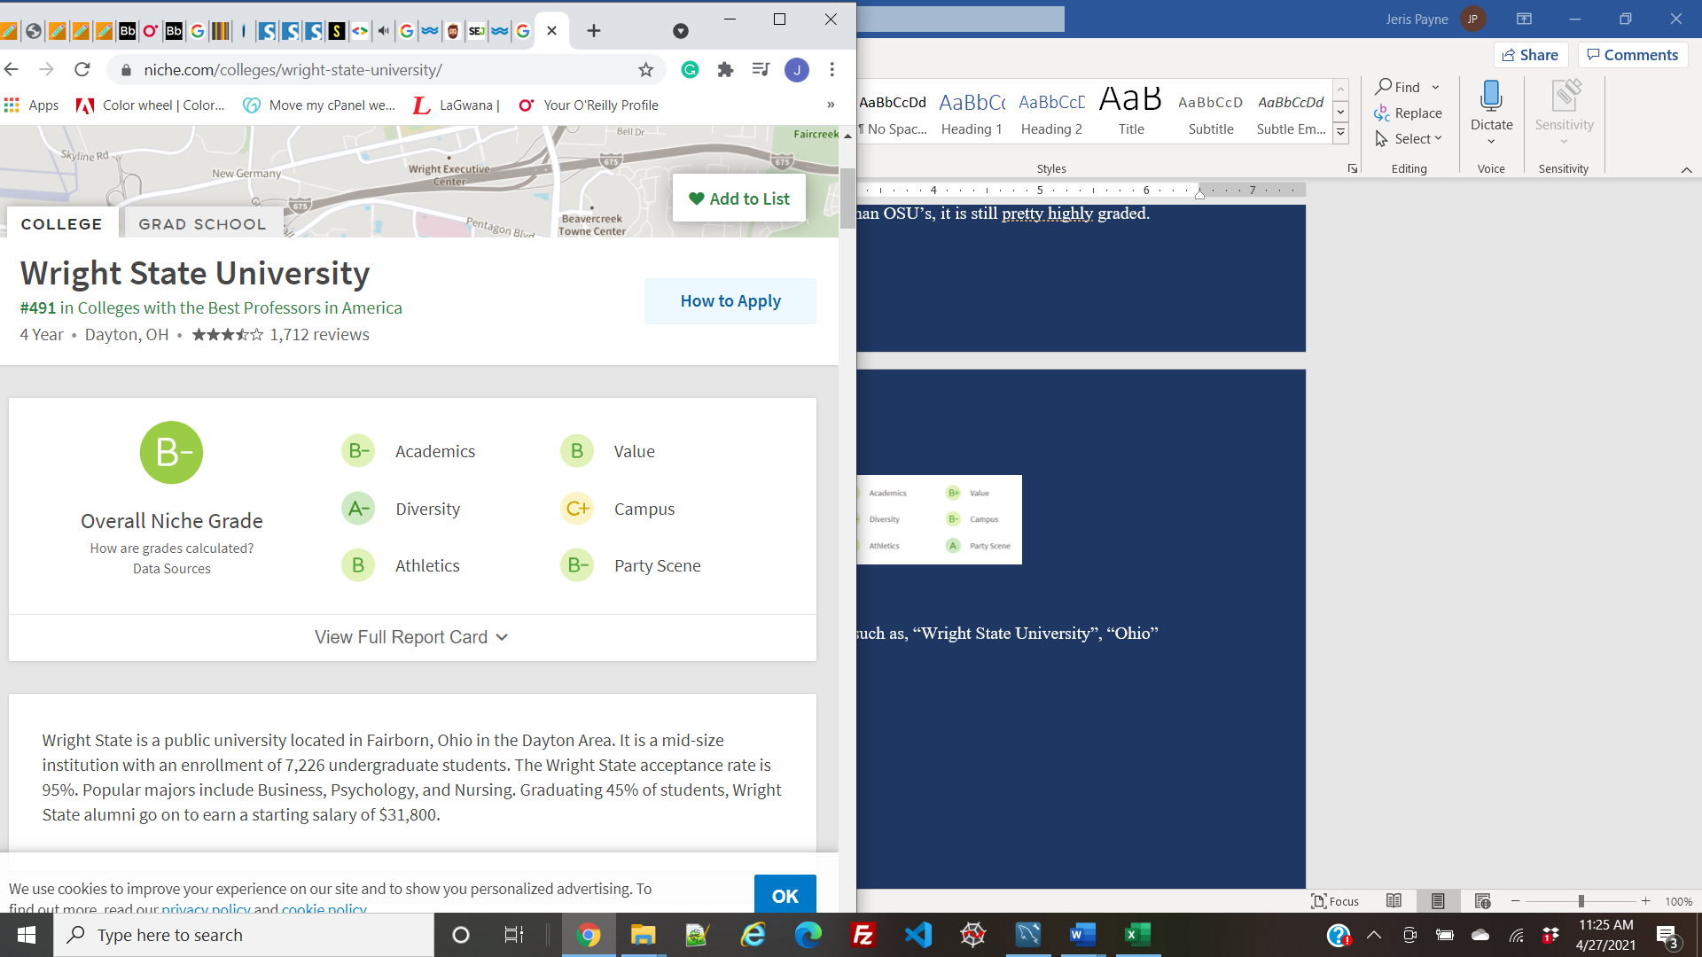

## Cedarville University

Cedarville uses keywords and phrases such as,

* “Christian”
* “university”
* “academics”
* “higher education”
* “Biblical truth”
* “spiritual”
* “CUGO”
* “nursing”
* “medical missions”
* “stewardship”
* “graduate program”
* “master’s degree”
* “yellow jackets”
* “lady jackets”
* “Cedarville yellow jackets”

Cedarville uses keywords that go along with their brand but are words that you typically might not see for a college. These words include,

* “Biblical truth”
* “spiritual”
* “stewardship”

These unique keywords can make Cedarville show up in more search results. They also have a large social media presence on all social platforms. Cedarville also has a high grade on Niche.com.

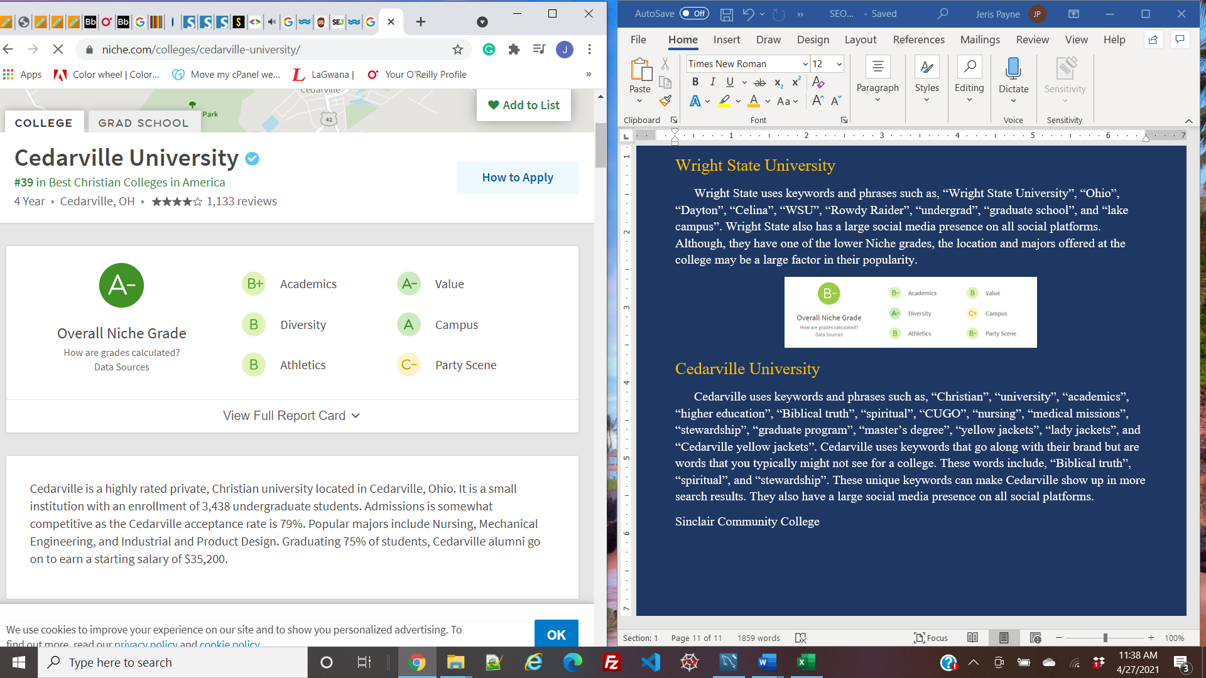

## Sinclair Community College

Sinclair has the most keywords out of all the colleges I reviewed therefore, I will not name all of them, just the ones that are different or unique. Sinclair uses keywords and phrases such as,

* “Sinclair.edu”
* “community colleges in Ohio”
* “online community college classes”
* “vocational schools in Ohio”
* “technical colleges in Ohio”
* “2-year colleges in Ohio”
* “campus life”
* “job search”
* “leadership training”
* “steps to filling out FAFSA form”
* “FAFSA workshop”

Sinclair uses some unique keywords such as their phone number and address which is something the other colleges did not use. Sinclair does have a large social media presence on all social platforms. They also have a grade of a B- on Niche.com which is higher than Clark State’s grade of a C+.

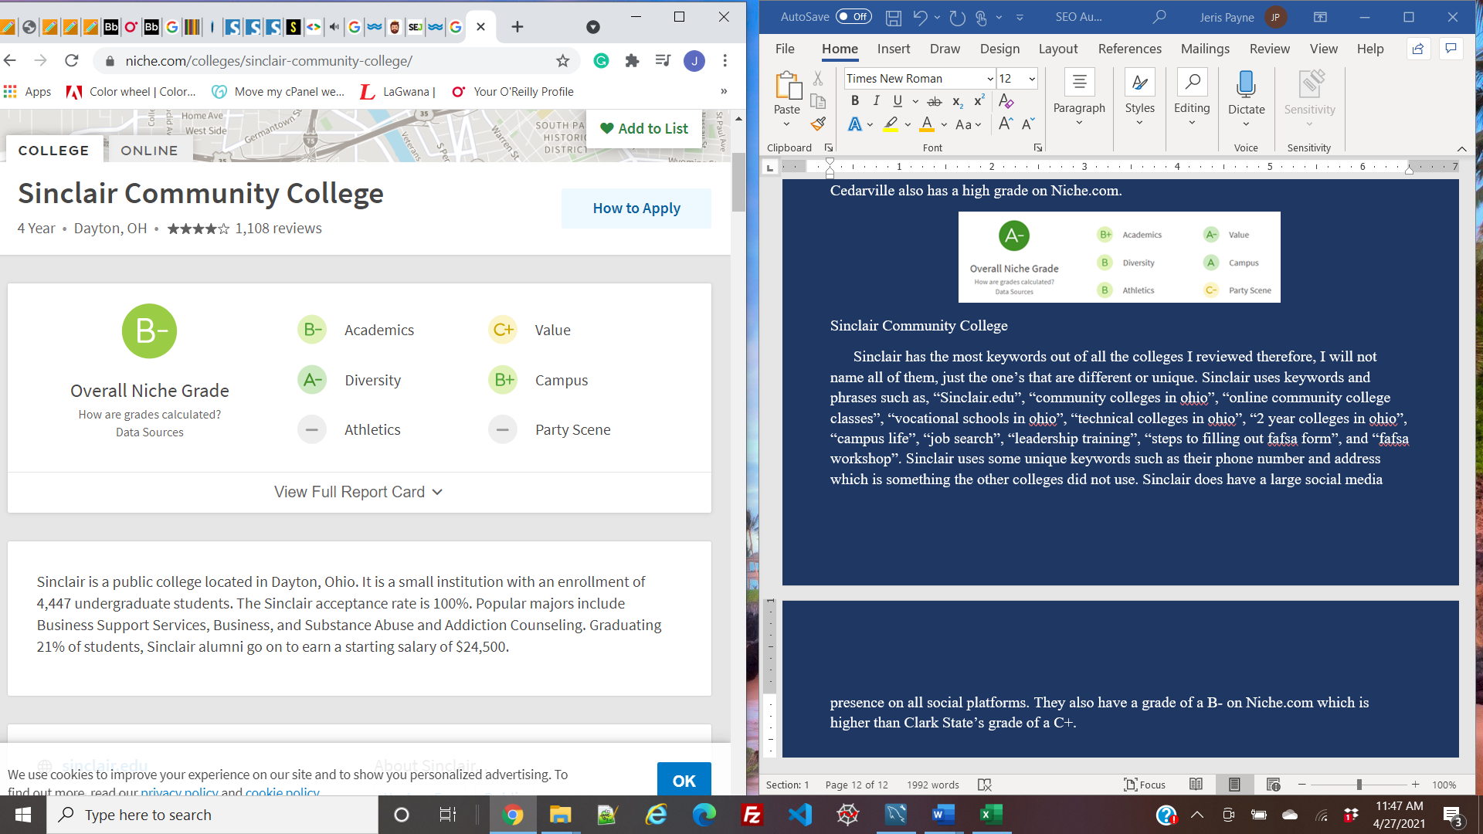

## Recommendations

To out rank competing colleges, I recommend pulling some ideas from the competitors. For example, Cedarville and Wight State included their locations and Sinclair included their online programs. These are keywords that Clark State can use too. Also, considering Clark State now offers bachelor degrees, it may be a good idea to include some bachelor-related keywords as well that way if a user is looking for a four-year college or one that offers a bachelors degree, Clark State has a chance at being displayed in the search results.

# **Robots.txt File**

A robots.txt file tells search engines which pages to crawl, and which pages not to crawl. This can be used to block non-public pages, block unimportant pages, and to prevent indexing of resources such as pdf files or images. A robots.txt file is important for SEO because it tells search engines how they can crawl your site the best.

## Results and Recommendations

Usually, you can find a robots.txt file by typing a website’s URL and adding /robots.txt to the end. When doing this for Clark State, I found that there is no robots.txt file. To fix this, I made a suggested robots.txt file that you can use or refer to for ideas. When coming up with ideas for what to include, I looked at other college’s robots.txt file to get some ideas. I also looked at the files that Clark State uses and added some directories that should not be crawled. I then referred back to the web pages that had 403 (forbidden) errors and added those to the file as well. Here is my suggested robots.txt file:

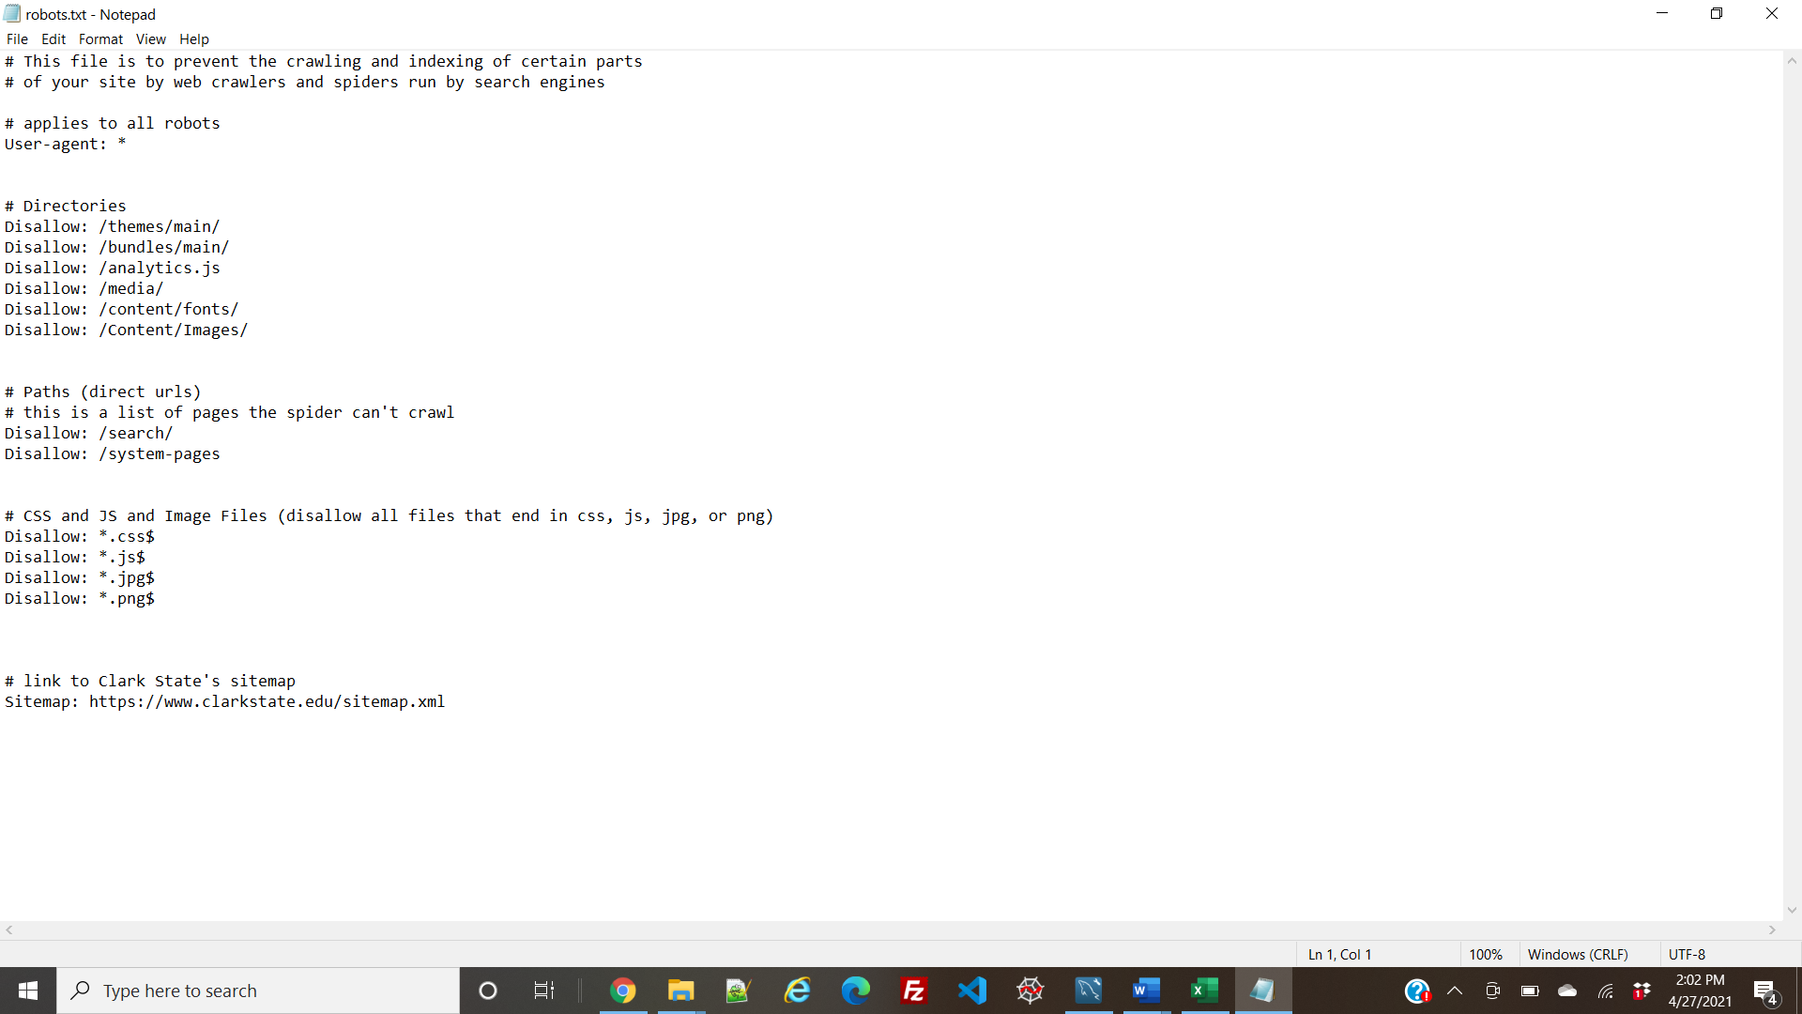

# **Mobile SEO Audit**

A mobile SEO audit is used to check your webpages as they are accessed from a mobile device and make sure that they work and display correctly. Since mobile devices are becoming more and more popular, it is very important to check how your website operates on a mobile device. Mobile SEO is important because Google has shifted to a “mobile-first index” which means that Google’s web crawlers will read your mobile site first. Having a mobile-friendly website will increase your rank in search results. To see if Clark State is mobile-friendly, I viewed the links on the home page on my mobile phone (an iPhone 11) and also on my desktop using Google’s browser tools to view the pages on various mobile devices.

## Problems and Aesthetic Issues

* <https://clarkstate.edu/> :
  + When viewing this page, I noticed that a few images were cut off when viewed on an iPad. To fix this I would change the width of the image or use the same CSS style as the other tablet brands because the website looked fine on those.
* <https://my.clarkstate.edu> :
  + When viewing this page, I noticed that the Clark State logo gets cut off when viewed on a Galaxy fold. I would also realign the logo on other screen sizes because at times it seems too big. I found that a width of 20px and a height of 105 px works just fine.
* <https://www.clarkstate.edu/admissions/enroll-now/> :
  + In the breadcrumb dropdown, it only displayed a link for “Undergraduate application” when there were other important links listed on the page that could have also been added. To fix this, I would include “College Credit Plus Application” and “International Application” in the dropdown as well.
* <https://www.clarkstate.edu/admissions/virtual-tour/> :
  + When viewing this page on my cell phone, I noticed the images were pixilated, though I think this had more to do with connectivity issues than issues with the website. The brochures also did not show up for the Galaxy phone view however the videos, contact, and share worked perfectly fine. I also noticed that the brochure video, contact, and share tabs looked very tiny and were almost hard to notice on tablets. To fix this I would use a media query to make them larger when viewed on tablet screen sizes. That way it is easier for the visually impaired to read.
* <https://www.clarkstate.edu/admissions/general-admissions/> :
  + When viewing this page on a Galaxy fold I noticed that the content is not evenly aligned on the page there's quite a bit of whitespace to the right of the content. The content fills the screen size again when the hamburger menu is opened however once it's closed the white space on the right side is back. The same thing happens when viewed on an iPhone 5 or an iPhone SE. To fix this I would add this to the CSS:
  + Html, body{

Width: 100%;

Height: 100%;

Margin: 0px;

Padding: 0px;

Overflow: hidden;

}

* <https://www.clarkstate.edu/academics/degrees-and-certificates/> :
  + The only thing to worry about is when you go to choose a location or a type, the page does zoom in and over expands and you can no longer see the hamburger menu until you close the location or the type. This only happens when viewing the page on my cell phone. After doing some research, I found out that this is something that commonly happens on iPhones. Below is some simple code to fix this issue which can be added to the header section of a page’s source code:

< meta name="viewport" content="width=device-width, initial-scale=1.0, maximum-scale=1.0,user-scalable=0"/>

* <https://www.clarkstate.edu/academics/class-schedule/> :
  + When viewing this page on my phone it seems responsive however I noticed in some areas you can scroll left and right which means it's not completely adjusting to the screen size. I would once again recommend trying to add overflow: hidden; to the CSS. Another problem is when you go to choose a semester or a subject it's like the page zooms in and then it doesn't zoom back out which makes the page go off the screen and once again the hamburger menu is cut off. The fix to this can be found in the last link.
* <https://clarkstate.edu/academics/class-schedule-planning/> :
  + Not everything on the page was centered when viewed on a Galaxy Fold. The subject, location, and time boxes are not centered correctly, and the “directed learning” column is not able to be seen because it overflows the page. After messing around in the developer tools I found that to fix this you need to change the style for .c-custom-table. I changed overflow to hidden, the font size to .6rem, and the left margin to -1.99 rem. This works for both the Galaxy fold and the iPhone 5/SE.
* <https://www.clarkstate.edu/financial-aid/applying-for-federal-financial-aid/> :
  + The page title is cut off when viewed on a Galaxy Fold or an iPhone 5/SE because it is so long. To fix this, I recommend making the title shorter if possible.
* <https://www.clarkstate.edu/about-us/fast-facts/> :
  + When viewing this page on most mobile devices I noticed that if you were to scroll across any of the tables such as “credit students”, “cost”, “age”, etc. for some reason the tables move. The rest of the page doesn't seem to move just these tables. This is a simple fix, just add overflow: hidden to .c-custom-table in the CSS.
* <https://www.clarkstate.edu/about-us/mission-vision-guiding-principles/> :
  + When viewed on a Galaxy Fold and an iPhone 5/SE, the title is cut off due to its length. I recommend making this shorter if possible.
* <https://www.clarkstate.edu/about-us/contact-us/> :
  + When viewed on a Galaxy fold and an iPhone5/SE, the contact table overflows the page on the phone number side. You do have the option to scroll left or right which makes you able to see the phone numbers and read them, but it would be nice if you did not have to scroll at all. To fix this, in the style for .c-custom-table, change overflow to hidden, margin-left to -1.75rem, padding-left to .25rem, and font-size to 0.750rem.
* <https://www.clarkstate.edu/about-us/news/> :
  + On all devices, even desktops, the “Next” and “Previous” buttons are not aligned with the page number box. To fix this add align-items: flex-end to .c-pager.
* <https://www.clarkstate.edu/college-life/calendar/> :
  + There is trouble with the calendar being viewed on very small screens when it is a list. This is a problem, however, I don’t think it is anything significant because on mobile devices (excluding tablets) you don’t have the option to view the calendar as a list which means it is highly unlikely this will be a user problem.

## Rel=”alternate” Tags

A rel=”alternate” tag is used to establish a relationship between pages that have a different version of the same content. This can be used to connect mobile and desktop pages. Clark State’s website does not include any rel=”alternate” tags which means nothing is pointing to the mobile version of the web pages. I recommend including some rel=”alternate” tags in the code.

## Rel=”canonical” Tags

Rel=”canonical” tags tell search engines that certain URLs are the same. Using canonical tags helps your rankings because they prevent duplicate content issues. The page with the canonical tag tells the browser that this is the original or preferred page. Clark State does not include any canonical tags which may be harming Clark State’s ranking. I recommend adding canonical tags to any duplicate web pages.

## Google Mobile-friendly Test

I used Google’s mobile-friendly test to determine Clark State’s ability to appear on mobile devices. I found redirection errors for the CSS file <https://cloud.typography.com/7938116/7055612/css/fonts.css>. When looking at the source code, I found that clicking this link leads to a 403 forbidden error. To fix this error you may need to change permissions on the CSS folder or for this specific CSS file. Or this file could be unauthorized from the public for a reason. What you could try doing is rechecking the address to make sure it is correct. It’s also possible that the error has been cached in your browser so you could try clearing your browser cookies and cache and reloading the page. If you don’t have permission to access the URL, then you may have to contact the person who created the website.

## Google’s Mobile Speed Test

On a 4G connection, the mobile speed is 1.8 seconds which is a good rating. To improve the speed, you can reduce the total size of network requests, preload requests, and efficiently encode images. You could also use a CDN to redirect the user requests to the nearest server. Moving your website to a better host could also improve page speed. You could also minimize the number of JavaScript and CSS files by trying to group all the JavaScript files into one and doing the same with the CSS files. This will help reduce the number of HTTP requests. Reducing the number of redirects and 404 errors would also increase site speed.

On a 3G connection, the mobile speed 3.5 seconds which could be better. You can improve the site speed by applying the same steps mentioned previously. It may also be helpful to measure and minimize server response time. This can be done by improving your web server software/configuration, enhancing your web hosting service, or reducing the number of resources required by your website. You can also load the content a mobile user would see first before the content they might see later this allows the user to experience the content sooner even if the page is still incomplete.

## Mobile First Index Tool

I used the mobile-first index tool found at <https://technicalseo.com/tools/mobile-first-index/> to get some more thorough results about the page speed. It resulted in a few errors.

* + The First Contentful Paint is slow which means it takes too long from the navigation to the page to the time the first bit of content is rendered from the DOM. You can fix this problem by decreasing the amount of render-blocking external CSS and scripts your page depends on. You can do this by making sure to keep your CSS small and use queries to unblock rendering. It is also important to minify or compress your HTML, CSS, and JavaScript files.
  + The Largest Contentful Paint is also slow. This regards the biggest visual part of the page which can often be an image or a block of text. To improve the LCP speed, you can activate a CDN to allow a user to get content from a server that is closest to them. A CDN would also allow you to cache your HTML so it does not have to reload every time which would also save time. Optimizing, compressing, and minimizing content would also benefit the LCP the same way it does the FCP.
  + The Total Blocking Time is 2,170ms. To correct this problem, we need to determine the long tasks, code blocks, and web page assets that are causing them. Reducing requests and the size of third-party scripts can help optimize the total blocking time. The impact of third-party code can significantly impact load performance. An example of a third-party script could be the video on the home page if it comes from YouTube. Minimizing the main thread work by reducing the time spent parsing, compiling, and executing JavaScript can also help reduce time.
  + There is also an error about certain image elements not having an explicit width and height. Setting the width and height can improve the CLS.
  + The report also gives other suggestions to improve Clark State’s rating. This includes serving images in next-gen formats such as JPEG 2000, JPEG XR, and WebP to provide better compression. It also suggests preloading key requests to prioritize fetching resources that are requested later in the page load.

# **Overall Recommendations**

To better Clark State’s SEO, I recommend first addressing the robots.txt file, response codes, and keywords since these will affect your ranking in search engines and your ranking against competitors. Adding a robots.txt file will tell Google to ignore duplicate pages which will increase your ranking. Keywords will also help clarkstate.edu show on more search results increasing the chance of someone finding and possibly even attending Clark State. You can look at your competitor’s keywords to get ideas or come up with a list of keywords that may be valuable to clarkstate.edu. Next, I recommend addressing the errors that were found when running Google’s mobile-friendly test, speed test, and mobile-first index test. Improving mobile speed will increase Clark State’s mobile-friendliness and user experience increasing the chances of a user visiting again and leaving satisfied. Improving your mobile-first indexing will also improve your rankings since Google’s crawlers read your mobile site first. Finally, you can address the little aesthetic issues that were mentioned in the mobile audit. This will also improve the user interface and tidy up the small styling issues to help Clark State’s website look that much closer to perfection.